DETAILED REPORT:

ShopNest Store Power BI Capstone:

“Insights on ShopNest as

Leading Department Store

in

E-Commerce Marketplace in Portugal.

PREPARED BY:
SAURAV DHALL

Question 1: Identify and visually represent the top 10 product categories by total sales.
Solution: Each product category by total sales value (total price) is displayed in this bar graph. The categories are displayed in descending order, that showing a quick comparison of sales contribution across the different segments of product.
According to the data, the best-performing product category is health beauty, which generates the highest overall price of almost 1.28 million. With a total sale of almost 1.2 million, watches gifts come in second, indicating that it also contributes significantly.At about 1.05 million, the bed bath table category of product comes in third, demonstrating steady performance.Furniture decor’s sales nearly 0.75 million, cool stuff almost 0.62 million and housewares just about 0.61 million. These categories show moderate performance.
Overall, the clearly highlights which product categorieshealthbeauty, watchesgifts, and bedbathtable drive the majority contribution of total sales, while categories like auto and gardentools contribute the least.
Visualization: Product Category by total price.
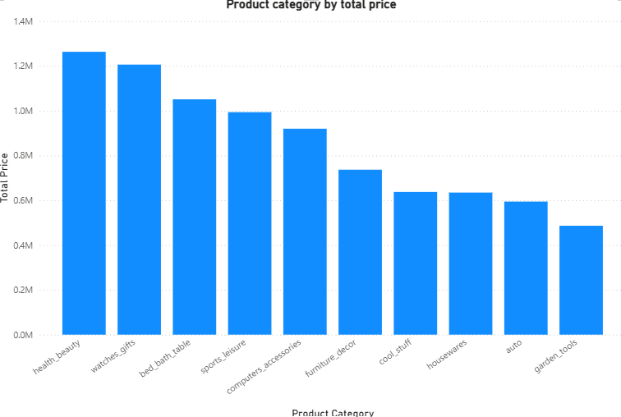

Question 2: Determine the number of delayed orders in each category. An order isconsidered delayed if the actual date is later than the estimated delivery date.
Solution: The number of delayed orders for each product category is shown in this bar graph. As the categories are organized in horizontal axis (x- axis) whereas, the order counts are in vertical axis(y-axis), it is simple to compare which portions encounter delays most.
According to the analysis, bed bath table product category has the greatest number of delayed orders nearly 780 orders making it the most affected product category. Followed by health beauty, which likewise displays a high delay count of roughly 740 orders. Other categories with significant delay levels include: Furniture decor almost 560 orders, Sports leisure next to 520 delayed orders, Computer’s accessories closely480 orders, Watches gifts more than 400 delayed orders.
Further down the chart, categories such as telephony, auto, gardentools, toys, baby, and coolstuff show moderate delay counts ranging between 200–300 order delays. Music instruments, luggage accessories, and audio show the lowest delayed order, typically under 80 orders. These categories demonstrate stronger delivery performance order volumes overall.
Visualization: Delayed orders in Each Category
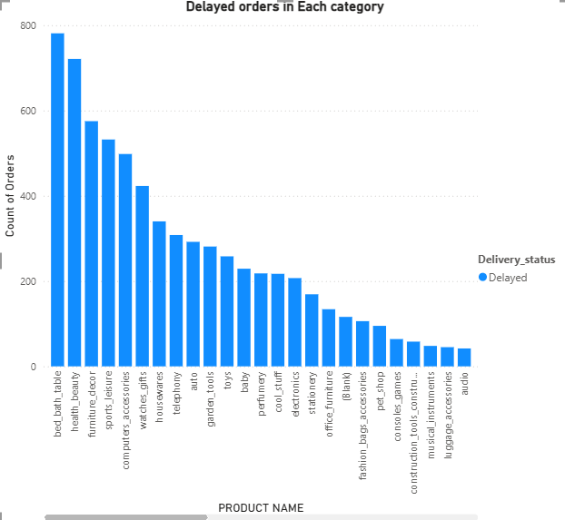
Question 3: Create a dynamic visual that compares the number of delayed orders to the number of orders received earlier for each month. Utilize the drill through cross-report to provide a detailed analysis of late and on-time deliveries.
Solution: The table summarizing the number of delayed and early deliveries across 12 months, along with the total deliveries for each month. The table has four columns: Month represents the month number that extract from the timestamp, Delayed represents the count of deliveries that were late, Early shows the count of deliveries that were on time or ahead of schedule and Total represents the sum of Delayed and Early deliveries for that month.
Month 8 has the highest total number of deliveries at 12214, whereas, Month 9 has the lowest total number of deliveries at 4873, followed by Month 12 (6320) and Month 10 (5737).At 1588, Month 3 has the most delayed deliveries, while Month 6 has the fewest just 184.The first three months 1, 2 and 3 show the highest counts of delayed deliveries 489, 1115, and 1588, respectively. However, In Early deliveries, Month 8 has the highest number of deliveries like 11647, but in Month 9 has the lowest number of early deliveries at 4662.
Overall Performance, the total number of deliveries across the 12 months is 113322. That the combination of 106028 deliveries were early and 7294 deliveries were delayed.
Visualization: Analysis of delayed and early deliveries.
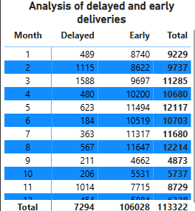

Question 4: Analyse the most frequently used payment methods by customers using a visually appealing representation, such as pie chart or other suitable visuals.
Solution: 1. Figure 4 illustrates the distribution of payment methods used by customers. In this chart visually highlights the proportion of orders attributed to each payment type such as credit card, boleto, voucher, debit card etc. According to the analysis, credit cards account for 76.8K orders, making them the most often used payment method,which represents 73.92% of all transactions. This ratio indicates that most consumers prefer to make purchases with credit cardseither for simplicity of use or offers.
2. The second most common payment method is bole to, contributing 19.78K orders (19.04%). This is a widely used alternative payment method.
3. Other Payment method depicts that voucher accounts for 5.78K orders (5.56%) and debit card usage is minimal at 0K%.
Overall, this chart highlights a strong dependence on credit card payments, followed by boleto.
Visualization: Payment Method Analysis
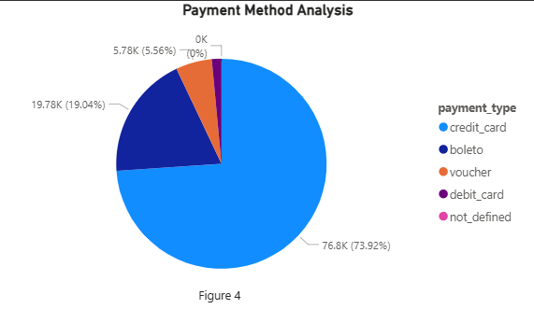

Question 5: Determine the top 10 highest-rated products and bottom 10 lowest-rated products using a bar chart or column chart.
Answer: TOP 10: cds_dvds_musicais has the highest rated score at 4.64, followed by 4.5 rated score for fashion_children_clothes, and 4.26 rated score for fashion_sport. Flowers, arts and craftsmanship has the rated score between 4.10 to 4.25.
Bottom_10: Services and security has the lowest average review score by a significant margin at 2.50. The scores exhibit a wide range, from the highest of 4.64 down to the lowest of 2.50, highlighting substantial differences in customer experience across the product categories. The difference between the highest and lowest score is 2.14 points.
Visualization: Top and bottom of rated product.

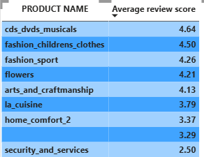

Question 6: Identify and visually represent states with high and low sales, providing a clear understanding of regional sales performance.
Solution: This bar chart provides a State-wise Sales Analysis, showing the breakdown of Total Price for various states, categorized by a Status of either High or Low. The vertical axis y-Axis (Total Price) Shows the total sales value in millions, up to $3.5 million. On the vertical axisx-axis (State) SP, RJ, RS, PR, SC, and BA, are listed.
SP (Sao Paulo) shows the highest overall price, this state dominates the sales table.The bar reaches approximately 3.25 million. Followed by RJ (Rio de Janeiro) is the second-highest sales state just above 1.2 M.Total sales in states like PR, SC, and BA range from roughly 0.3 M to 0.45 M.In states like SC, the “High” status sales are marginally higher than the “Low” status sales. The total price of “High” status of PE is slightly higher than the ES state. States toward the end of the chart, such as AL, SE, TO, and RO, have minimal price for the status.
Visualization: State-wise sales Analysis.
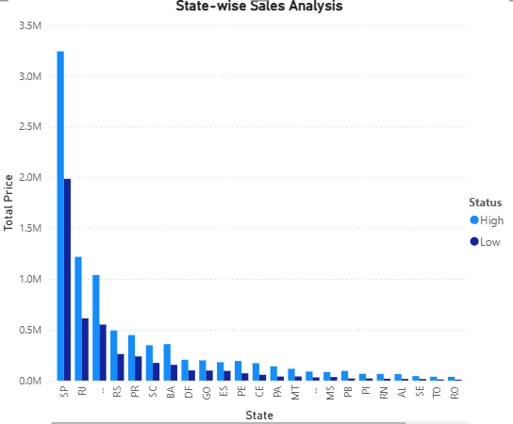

Question 7: Investigate and visualize any seasonal patterns (Quarterly) or trends in sales data over the course of the year.
Solution: The bar chart titled "Total orders by Year and Quarter" illustrates the trend of total orders over time i.e., year and quarter. Meanwhile, x-axis represents the Quarter/Year and y-axis represents the total orders, ranging from 0 to 30,000. In 2016 Q3, orders seem to be almost non-existent (less than 1,000). But, in Q4 orders have slightly increased, although they are still less than 1,000. In 2016, there were very few orders overall. Furthermore, in 2017 Q1, orders increase dramatically to between 5,500 and 6,000, but in Q2 and Q3, maintains the growth, hitting over 14500. In Q4, orders reach their annual high just over 20000.
In 2018 Q1, orders hit about 24,500, the highest level as compared to year 2016 and 2017. This is the highest quarter in terms of overall orders. But in Q2 and Q3, orders have significantly decreased, reaching about 14,500. This number is about the same as it was in Q3 of 2017.

Visualization: Total order by Year and Quarter.
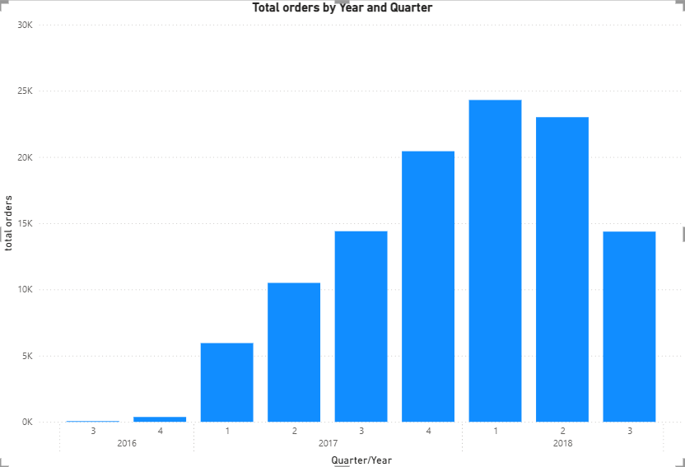

Question 8: Determine the total revenue generated by ShopNest Store and analyse how it changes overtime (Yearly). Represent this information through suitable visuals to highlight trends and patterns.
Solution: The line graph titled “Total Revenue by Year” illustrates the total revenue trend over a three-year period, from 2016 to 2018.Where X-Axis (Year) showsthe timeline spans three years: 2016, 2017, and 2018. Whereas, Y-Axis (Total Revenue) depicts revenue that is measured in millions (M), ranging from 0M up to 8M.
The starting revenue is shown as 0M, indicating either the beginning of operations or the first year. By 2017, revenue had climbed to 7.2 million, a dramatic jump from 2016 and the period of fastest growth. In 2018, revenue continued to rise, reaching 8.7M, though at a more moderate pace.
Overall Trend: The total revenue shows a consistent and positive upward trend over the three years.
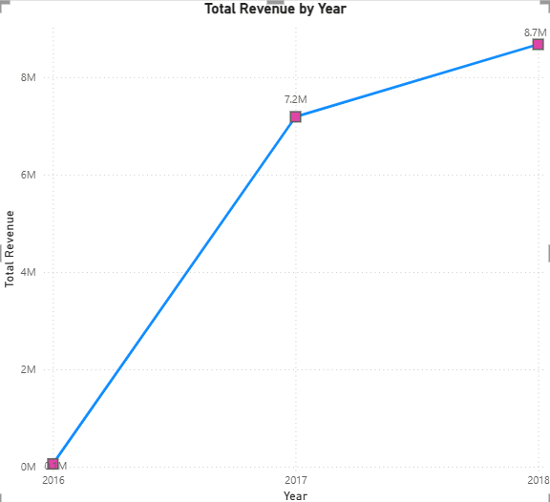
Visualization: Total Revenue by year.

Dashboard View:

